“User Management System”

Software Requirements Specification

25 April 2024

Raghav Gupta
(12215792)

Prepared for
Continuous Assessment 3
Spring 2024

Revision History

Date | Description | Author | Comments
<date> | <Version 1> | <Your Name> | <First Revision>

Table of Contents

Revision History ii
1. Introduction 1
1.1 Purpose 1
1.2 Scope 1
1.3 Definitions, Acronyms, and Abbreviations 1
1.4 References 1
1.5 Overview 1
2. General Description 2
2.1 Product Perspective 2
2.2 Product Functions 2
2.3 User Characteristics 2
2.4 General Constraints 2
2.5 Assumptions and Dependencies 2
3. Specific Requirements 2
3.1 External Interface Requirements 3
3.1.1 User Interfaces 3
3.1.2 Hardware Interfaces 3
3.1.3 Software Interfaces 3
3.1.4 Communications Interfaces 3
3.2 Functional Requirements 3
3.2.1 <Functional Requirement or Feature #1> 3
3.2.2 <Functional Requirement or Feature #2> 3
3.5 Non-Functional Requirements 4
3.5.1 Performance 4
3.5.2 Reliability 4
3.5.3 Availability 4
3.5.4 Security 4
3.5.5 Maintainability 4
3.5.6 Portability 4
3.7 Design Constraints 4
3.9 Other Requirements 4
4. Analysis Models 4
4.1 Data Flow Diagrams (DFD) 5
5. Github link…………………………………………………………………………………………………….5
A. Appendices 5
A.1 Appendix 1 5
A.2 Appendix 2 5

1. Introduction.
.
In today's digital age, managing user data efficiently is paramount for organizations of all sizes. Whether it's a small startup or a large corporation, the ability to seamlessly add, update, delete, and search for user information is crucial for smooth operations. The User Management System (UMS) aims to address this need by providing a comprehensive solution for managing user data effectively.

1.1 Purpose
The purpose of your User Management System (UMS) project is to develop a robust and efficient platform for managing user data within an organization. By leveraging modern technologies such as Node.js and MongoDB, the system aims to streamline the process of adding, updating, deleting, and searching for user information.

1.2 Scope
Software Product(s) Identification
- The software product under consideration is a user management system developed using Node.js, Express, and MongoDB.
- It facilitates the management of customer records, including adding, viewing, editing, and deleting customer data.

Functionality
- **User Management:**
- Allows users to perform CRUD operations on customer records.
- Users can add new customers, view existing customer details, edit customer information, and delete customer records.
- **Homepage:**
- Displays a list of customers on the homepage.
- Implements pagination to manage large datasets efficiently.
- **Search Functionality:**
- Enables users to search for customers by first name or last name.

Application Description
The application provides a web-based interface for managing customer data.
- It follows a Model-View-Controller (MVC) architecture, with models representing data, views handling user interfaces, and controllers managing business logic.
- Key components include routes for defining application endpoints, controllers for handling HTTP requests, models for interacting with the database, and views for rendering HTML templates.
- The system is designed to be user-friendly, allowing users to intuitively navigate through different functionalities.

With this expansion, we've clarified the scope of the project, identified the software product(s) involved, detailed its functionality, and provided a description of the application. Let me know if you need further elaboration or if there are any additional sections you'd like to include!

1.3 Definitions, Acronyms, and Abbreviations

- User management system: The user management application being developed.

- SRS: Software Requirements Specification - A document outlining the requirements for the user management application.

- Express: A web application framework for Node.js used to build the backend of Todoist.

- Mongoose: An Object Data Modeling (ODM) library for MongoDB and Node.js, used for database operations in user management application.

- EJS: Embedded JavaScript - A templating language used for generating HTML markup with JavaScript in user management application.

- Body-parser: A middleware for parsing incoming request bodies in a middleware stack, used in user management application for parsing URL-encoded data.

- HTTP: Hypertext Transfer Protocol - The protocol used for transmitting data between a client and a server in user management application.

- HTML: Hypertext Markup Language - The standard markup language for creating web pages and web applications.

- CSS: Cascading Style Sheets - A style sheet language used for describing the presentation of a document written in HTML in user management application.

- JavaScript: A programming language commonly used for creating interactive effects within web browsers, used extensively in user management application for client-side scripting.

- Node.js: A JavaScript runtime environment used for server-side scripting in user management application.

- MongoDB: A NoSQL database used as the backend database for storing data in user management application.

- CRUD: Create, Read, Update, Delete - The four basic functions of persistent storage, used in database operations in user management application.

- URL: Uniform Resource Locator - A reference to a web resource that specifies its location on a computer network and a mechanism for retrieving it, used for routing requests in user management application.

- API: Application Programming Interface - A set of rules and protocols for building and interacting with software applications, potentially used for integrating user management application with other services.

- UI: User Interface - The graphical interface through which users interact with user management application.

- UX: User Experience - The overall experience of a person using user management application, including ease of use, accessibility, and satisfaction.

1.4 References

- [W3Schools] (https://www.w3schools.com/ )
- [MongoDB Documentation] (https://docs.mongodb.com/ )
- [Express Documentation] (https://expressjs.com/en/4x/api.html )
- [Mongoose Documentation] (https://mongoosejs.com/docs/guide.html )
- [Node.js Documentation] (https://nodejs.org/en/docs/ )
- [EJS Documentation] (https://ejs.co/ )
- [Body-parser Documentation] (https://www.npmjs.com/package/body-parser )

1.5 Overview

The Node.js User Management Express EJS project is a web application designed to facilitate the management of customer records. Leveraging the power of Node.js, Express, and MongoDB, the application provides a robust platform for businesses or organizations to efficiently handle customer data.

At its core, the project aims to streamline the process of managing customer information, offering functionalities for adding new customers, viewing existing records, editing details, and removing entries as needed. Through a user-friendly interface, users can navigate seamlessly across different features, ensuring a smooth and intuitive experience.

With its focus on simplicity, performance, and usability, the Node.js User Management Express EJS project serves as a versatile solution for businesses seeking an effective means of organizing and managing their customer data. Whether used in small-scale enterprises or larger organizations, the project offers a reliable framework for optimizing customer relationship management processes.

2. General Description

2.1 Product Perspective
1. Provides specialized tools for businesses to efficiently organize and manage customer data.
2. Enhances operational efficiency by streamlining data management processes.
3. Improves customer service through personalized interactions and faster response times.
4. Fosters stronger client relationships by leveraging comprehensive customer insights.
5. Contributes to the broader objectives of businesses by optimizing CRM practices.
6. Supports operational excellence, superior customer service, and enhanced client engagement.
7. Aligns with industry trends focused on leveraging data for improved business outcomes.

2.2 Product Functions
1. **User Management:**
- Facilitates CRUD operations for managing customer records, including adding, viewing, editing, and deleting customer data.

2. **Homepage Display:**
- Renders a paginated list of customers on the homepage for easy access and navigation.
- Implements pagination to efficiently manage large datasets and improve performance.

3. **Search Functionality:**
- Enables users to search for specific customers by first name or last name, enhancing data accessibility and retrieval.

4. **Customer Details View:**
- Allows users to view detailed information about individual customers, providing insights into their profiles and interactions.

5. **Customer Editing:**
- Provides functionality for editing customer details, such as names, contact information, and additional details.

6. **Customer Deletion:**
- Enables users to delete customer records when necessary, maintaining data integrity and cleanliness.

7. **Customization Options:**
- Offers customization options to adapt the application to specific business requirements and workflows.

8. **Flash Messaging:**
- Utilizes flash messages to provide feedback to users upon successful operations or error handling.

9. **Error Handling:**
- Implements robust error handling mechanisms to ensure smooth user experience and prevent data loss or corruption.

10. **Security Measures:**
- Incorporates security measures to protect sensitive customer data, such as encryption and authentication mechanisms.

These functions collectively form the core functionality of the Node.js User Management Express EJS project, empowering users to efficiently manage customer data and enhance their CRM processes.

2.3 User Characteristics
- Manage the entire system including user accounts, permissions, and configurations.
- Perform CRUD operations on customer records.
- Require advanced technical skills to oversee and maintain the application effectively.

2.4 General Constraints
1. **Resource Constraints:**
- Limited availability of hardware resources such as memory, processing power, and storage may impact system performance.
- Budget constraints may restrict the acquisition of additional resources to scale the system.

2. **Time Constraints:**
- Project deadlines and time-to-market requirements may impose limitations on the development and deployment phases.
- Limited time for testing and debugging may affect the overall quality and reliability of the system.

3. **Technical Constraints:**
- Compatibility issues with existing software or hardware environments may restrict technology choices or integration capabilities.
- Dependencies on third-party libraries or services may introduce constraints related to version compatibility and licensing.

4. **Regulatory Constraints:**
- Compliance with industry regulations and standards, such as data protection laws (e.g., GDPR, HIPAA), may impose constraints on data handling and security measures.
- Legal constraints related to intellectual property rights, licensing agreements, and export regulations may influence system design and implementation.

5. **Operational Constraints:**
- Geographic constraints, such as time zone differences and regional regulations, may impact system availability and support.
- Operational policies and procedures, including maintenance schedules and downtime windows, may impose constraints on system operation and maintenance activities.

6. **Security Constraints:**
- Security requirements, such as encryption standards and access controls, may impose constraints on system design and implementation to ensure data confidentiality and integrity.
- Compliance with security best practices and industry standards may introduce additional constraints on system architecture and functionality.

7. **Scalability Constraints:**
- Limitations in scalability may restrict the system's ability to accommodate growing user bases or increasing data volumes.
- Scalability constraints may arise from architectural decisions, database design, or resource limitations.

8. **User Experience Constraints:**
- User experience constraints, such as accessibility requirements and usability guidelines, may influence the design and development of the user interface.
- Compatibility with different devices, screen sizes, and input methods may impose constraints on UI/UX design decisions.

2.5 Assumptions and Dependencies
**Assumptions:**

1. **Stable Internet Connectivity:**
- It is assumed that users will have stable internet connectivity to access the application without interruptions.

2. **Data Accuracy:**
- Assumption is made that the data entered by users is accurate and up-to-date, ensuring the integrity of the information stored in the system.

3. **User Authentication:**
- Assumption is made that proper user authentication mechanisms are in place to prevent unauthorized access to sensitive data and functionalities.

4. **Compliance with Regulations:**
- It is assumed that the system will comply with relevant data protection regulations and industry standards to ensure the security and privacy of user data.

5. **Hardware and Software Compatibility:**
- Assumption is made that the hardware and software components used to deploy the application are compatible with each other and meet the system requirements.

**Dependencies:**

1. **Third-party Libraries and Frameworks:**
- The project may depend on external libraries and frameworks for functionalities such as authentication, database management, and user interface design.

2. **Database Management System (DBMS):**
- Dependency exists on the chosen database management system (e.g., MongoDB) for data storage, retrieval, and management.

3. **Hosting Platform:**
- Dependency on a hosting platform (e.g., AWS, Heroku) for deploying the application and ensuring its availability to users.

4. **APIs and External Services:**
- Dependency on external APIs and services for functionalities such as email notifications, payment processing, or geolocation services.

5. **Development Tools and Environments:**
- Dependency on development tools and environments (e.g., Node.js, Express.js, EJS) for building and testing the application.

6. **User Feedback and Testing:**
- Dependency on user feedback and testing processes to identify and address issues, validate assumptions, and improve the overall quality of the application.

7. **Project Stakeholders:**
- Dependency on project stakeholders for providing requirements, feedback, and approvals throughout the development lifecycle.

3. Specific Requirements

3.1 External Interface Requirements

3.1.1 User Interfaces

- **Homepage:** Displays a list of customers with pagination for easy navigation. Users can view, add, edit, and delete customer records from this interface.
- **About Page:** Provides information about the User Management System.
- **New Customer Form:** Allows users to add a new customer by providing their details such as first name, last name, telephone, email, and additional details.
- **View Customer Data:** Displays detailed information about a specific customer, including their first name, last name, telephone, email, and additional details.
- **Edit Customer Data:** Allows users to edit the details of an existing customer.
- **Search Customer Data:** Enables users to search for specific customers based on their first name or last name.

3.1.2 Hardware Interfaces
- The application does not have specific hardware dependencies beyond standard computing devices such as desktops, laptops, tablets, or smartphones.
- Users can access the application using any device with a web browser and an internet connection.

3.1.3 Software Interfaces
The application is built using the following software components:
- Node.js: The server-side JavaScript runtime environment.
- Express.js: The web application framework for Node.js, providing routing and middleware capabilities.
- MongoDB: The NoSQL database management system used for storing task data.
- Mongoose: An Object Data Modeling (ODM) library for MongoDB, facilitating interactions with the database.
- EJS (Embedded JavaScript): The templating engine used for server-side rendering of dynamic HTML content.
- Body-parser: Middleware used for parsing incoming request bodies, particularly form data.

3.1.4 Communications Interfaces

- Web browsers: Users interact with the application through HTTP requests and responses.
- MongoDB database: The application communicates with the MongoDB database to perform CRUD (Create, Read, Update, Delete) operations on task data.
- External networks: The application may communicate with external networks if deployed in a networked environment (e.g., accessing MongoDB Atlas cloud database).

3.2 Functional Requirements

**3.2.1 Add New Customer**

**3.2.1.1 Introduction**

This feature allows users to add a new customer to the system by providing their details through a web form.

**3.2.1.2 Inputs**

- First Name: String input representing the first name of the customer.
- Last Name: String input representing the last name of the customer.
- Telephone: String input representing the telephone number of the customer.
- Email: String input representing the email address of the customer.
- Details: Text input providing additional details or information about the customer.

**3.2.1.3 Processing**

Upon receiving the input data from the user, the system validates the inputs to ensure they meet the required criteria (e.g., non-empty fields, valid email format). Once validated, the system creates a new customer record in the database with the provided details.

**3.2.1.4 Outputs**

Upon successful addition of the new customer, the system redirects the user to the homepage, where they can view the updated list of customers. Additionally, a success message may be displayed to confirm the addition of the customer.

**3.2.1.5 Error Handling**

If any input validation fails (e.g., empty fields, invalid email format), the system displays appropriate error messages to the user, indicating the specific validation errors. The user is prompted to correct the errors before submitting the form again.

---

**3.2.2 View Customer Data**

**3.2.2.1 Introduction**

This feature allows users to view detailed information about a specific customer.

**3.2.2.2 Inputs**

- Customer ID: Unique identifier of the customer whose data is to be viewed.

**3.2.2.3 Processing**

The system retrieves the customer data from the database based on the provided customer ID. If the customer exists, their details are fetched and displayed to the user.

**3.2.2.4 Outputs**

The system presents the user with a view containing the customer's details, including their first name, last name, telephone, email, and additional details.

**3.2.2.5 Error Handling**

If the provided customer ID does not correspond to any existing customer record, the system displays an error message indicating that the customer data could not be found.

Certainly! Let's add a few more features to the Software Requirements Specification (SRS) document:

---

**3.2.3 Edit Customer Data**

**3.2.3.1 Introduction**

This feature allows users to edit the details of an existing customer.

**3.2.3.2 Inputs**

- Customer ID: Unique identifier of the customer whose data is to be edited.
- Updated Details: Updated values for the customer's first name, last name, telephone, email, and additional details.

**3.2.3.3 Processing**

The system retrieves the customer data based on the provided customer ID and presents the current details in an editable form. Upon submission of the updated details, the system validates the inputs and updates the corresponding customer record in the database.

**3.2.3.4 Outputs**

Upon successful update of the customer data, the system redirects the user to the view page for the edited customer, displaying the updated details. A success message may also be displayed to confirm the successful update.

**3.2.3.5 Error Handling**

If the provided customer ID does not correspond to any existing customer record, the system displays an error message indicating that the customer data could not be found. Additionally, validation errors are handled similarly to the Add New Customer feature.

---

**3.2.4 Delete Customer**

**3.2.4.1 Introduction**

This feature allows users to delete a customer from the system.

**3.2.4.2 Inputs**

- Customer ID: Unique identifier of the customer to be deleted.

**3.2.4.3 Processing**

The system retrieves the customer data based on the provided customer ID and prompts the user to confirm the deletion. Upon confirmation, the system deletes the corresponding customer record from the database.

**3.2.4.4 Outputs**

Upon successful deletion of the customer, the system redirects the user to the homepage, where they can view the updated list of customers. A success message may also be displayed to confirm the deletion.

**3.2.4.5 Error Handling**

If the provided customer ID does not correspond to any existing customer record, the system displays an error message indicating that the customer data could not be found.

Certainly! Let's add a few more features to the Software Requirements Specification (SRS) document:

---

**3.2.5 Search Customer Data**

**3.2.5.1 Introduction**

This feature allows users to search for specific customers based on their first name or last name.

**3.2.5.2 Inputs**

- Search Term: String input representing the search query entered by the user.

**3.2.5.3 Processing**

The system receives the search term entered by the user and performs a search operation in the database to find customers whose first name or last name matches the search term. The search is case-insensitive and may include partial matches.

**3.2.5.4 Outputs**

The system presents the user with a list of customers whose first name or last name matches the search term. Each customer entry includes relevant details such as their first name, last name, telephone, email, and additional details.

**3.2.5.5 Error Handling**

If no customers match the search criteria, the system displays a message indicating that no results were found for the given search term.

---

3.5 Non-Functional Requirements

3.5.1 Performance
- The system shall respond to user interactions (e.g., task creation, editing, deletion) within 500 milliseconds under normal load conditions.
- The application shall be capable of handling concurrent requests from multiple users, with a minimum throughput of 100 requests per second.

3.5.2 Reliability
- The system shall maintain data consistency and integrity, ensuring that task data is accurately stored and retrieved from the database.
- The application shall have a Mean Time Between Failures (MTBF) value of at least 30 days, indicating the system's reliability over time.

3.5.3 Availability
- The application shall have a minimum uptime of 99.9% per month, ensuring accessibility to users for the majority of the time.
- Planned maintenance windows, if any, shall be communicated to users in advance, and system downtime during maintenance shall not exceed 5 minutes per month.

3.5.4 Security
- User passwords shall be securely hashed and stored using industry-standard encryption techniques (e.g., bcrypt).
- The system shall implement proper authentication mechanisms to prevent unauthorized access to user accounts and sensitive data.
- Access to administrative functions (e.g., database management) shall be restricted to authorized personnel only.

3.5.5 Maintainability
- The code shall adhere to coding standards and best practices to facilitate readability and maintainability for future development efforts.
- Proper documentation shall be provided for codebase, including comments, README files, and API documentation, to assist developers in understanding and maintaining the system.

3.5.6 Portability
- The application shall be platform-independent and compatible with different operating systems (e.g., Windows, Linux, macOS) where Node.js and MongoDB are supported.
- Browser compatibility shall be ensured for popular web browsers such as Google Chrome, Mozilla Firefox, and Microsoft Edge, with consistent functionality and user experience across different browsers.

3.7 Design Constraints
Database Dependency:
- Relies on MongoDB (localhost:27017).

Port Dependency:
- Application listens on port 8080.

Environment Dependency:
- Requires Node.js setup.

Security Concerns:
- Limited security measures.

Maintainability:
- Code readability and documentation.

Deployment Considerations:
- Production setup and CI/CD

3.9 Other Requirements

- Documentation: Comprehensive documentation for developers and end-users, including architecture, functionalities, and usage instructions.
- Testing: Rigorous testing for functional correctness, performance, reliability, and security, with documentation of test plans and results.
- Version Control: Source code management using version control systems like Git for tracking changes and collaboration.
- Deployment and Release Management: Procedures for smooth deployment and release of new features, with deployment scripts and release notes.
- User Support and Training: Channels for user support and training materials to onboard new users and educate them about the system.
- Compliance and Regulations: Compliance with relevant laws, regulations, and industry standards, with documentation and certifications as necessary.
- Feedback Mechanism: Incorporation of a feedback mechanism to gather user feedback, suggestions, and feature requests for continuous improvement.

4. Analysis Models

4.1 Data Flow Diagrams (DFD)

Zero level DFD (Context Diagram):

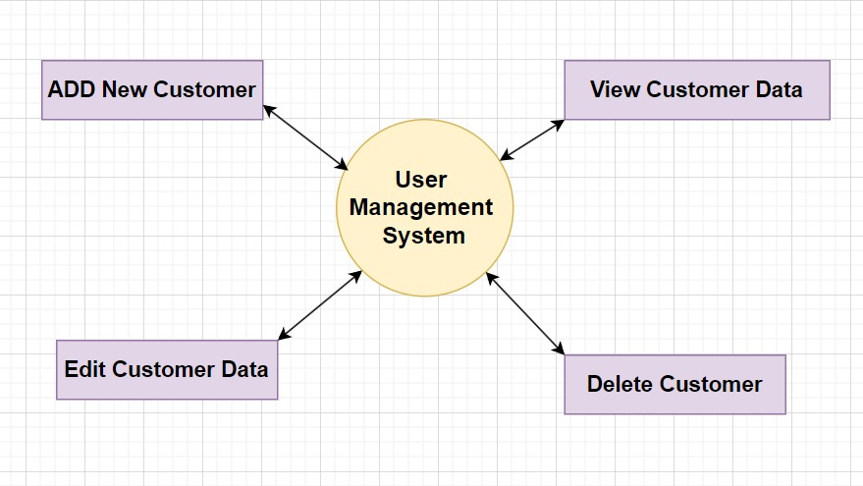

Level 1 DFD

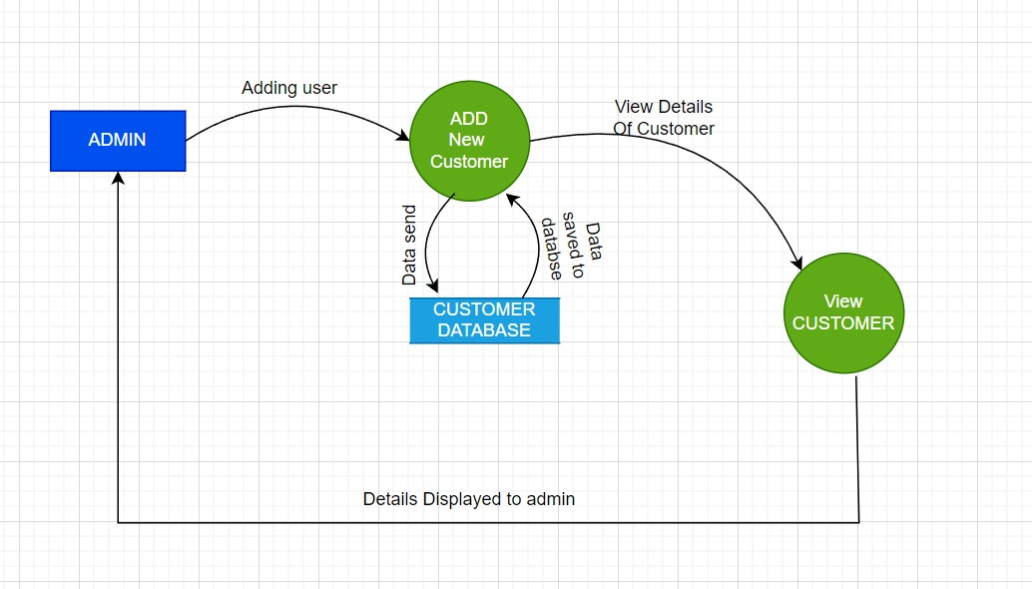

Level 3 DFD

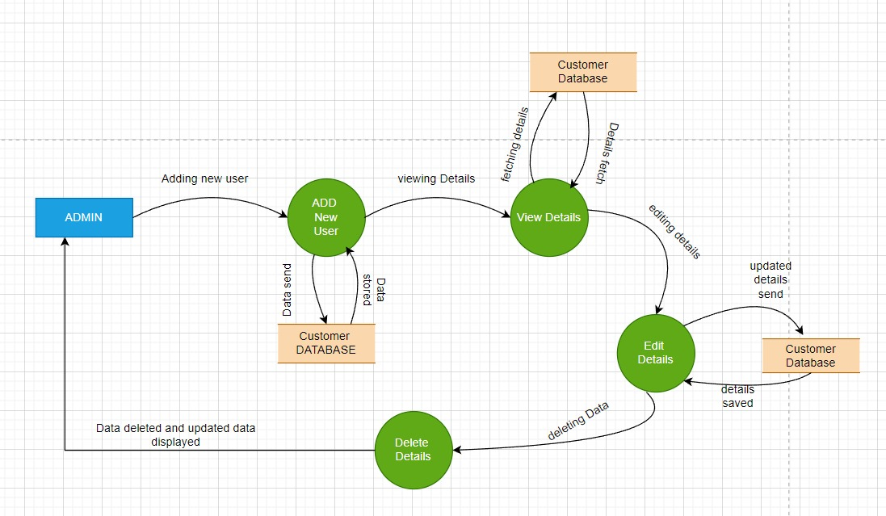

6. GitHub Link
https://github.com/Raghavgupta2003/Restaurant-website-KHAO-PIYO-

A. Appendices

A.1 Appendix 1: Database Schema
- This appendix provides the schema design for the MongoDB database used in the application.
- It includes details of the collections, documents, and fields utilized to store task data.

A.2 Appendix 2: Wireframes
- This appendix contains wireframes or mockups illustrating the user interface design of the application.
- It showcases the layout, structure, and interactions of different screens or pages within the application.

